Instructions for assignment 3 – Restoring AdventureWorks2014 Database and More Commands
EACH DELIVERABLE IS NOTED WITH TWO DOLLAR SIGNS IN FRONT ($$), IN RED

- USE THIS WORD DOC AND INSERT THE DELIVERABLES WHERE INDICATED (TO BE UPLOADED) – PLEASE NOTE THAT ALL SCREENSHOTS SHOULD BE FULL-SCREEN SCREENSHOTS (no cropped screenshots)
- Download the zipped backup file from https://github.com/Microsoft/sql-server-samples/releases/download/adventureworks/AdventureWorks2014.bak
- Save the file on some drive that is accessible to the database. The file should be named AdventureWorks2014.bak
- Start SSMS and log into your server
- Expand the server to provide a view into its components
- Right click on the “databases” line to get the following:
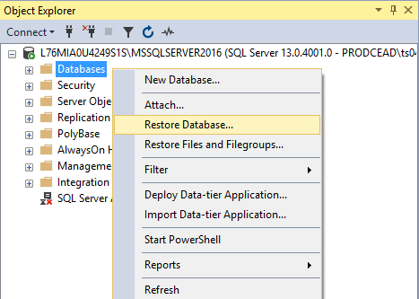
- Click on “Restore Database” and the following should appear:
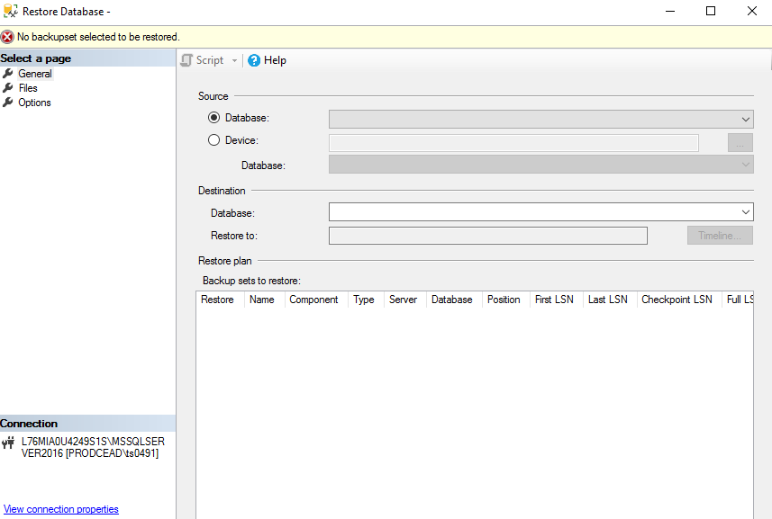
- Select “Device” as source, then click on the “…” box.
- Click “Add” on the next screen.
- Select the AdventureWorks2014.bak from wherever you unzipped it.
- Click “OK” and then click “OK” again on the next screen. You should then see something like the following:
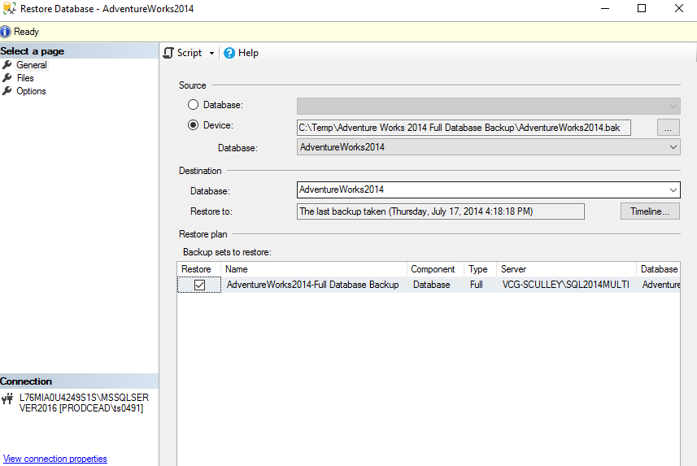
- Click “OK” again and the restore should proceed
- Afterwards, you should be able to expand the “Databases” line and see the “AdventureWorks2014” database as follows:
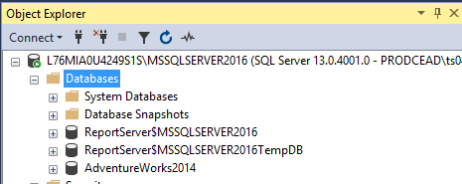
- ($$)DELIVERABLE - Take a screenshot of the entire SSMS interface with the “Databases” line expanded as well as the “AdventureWorks2014” database expanded and the “tables” line within it as well. You will not be able to show all the tables within the AdventureWorks2014 Database within one screenshot, but that’s fine. Place the screenshot just below this point in this word doc:
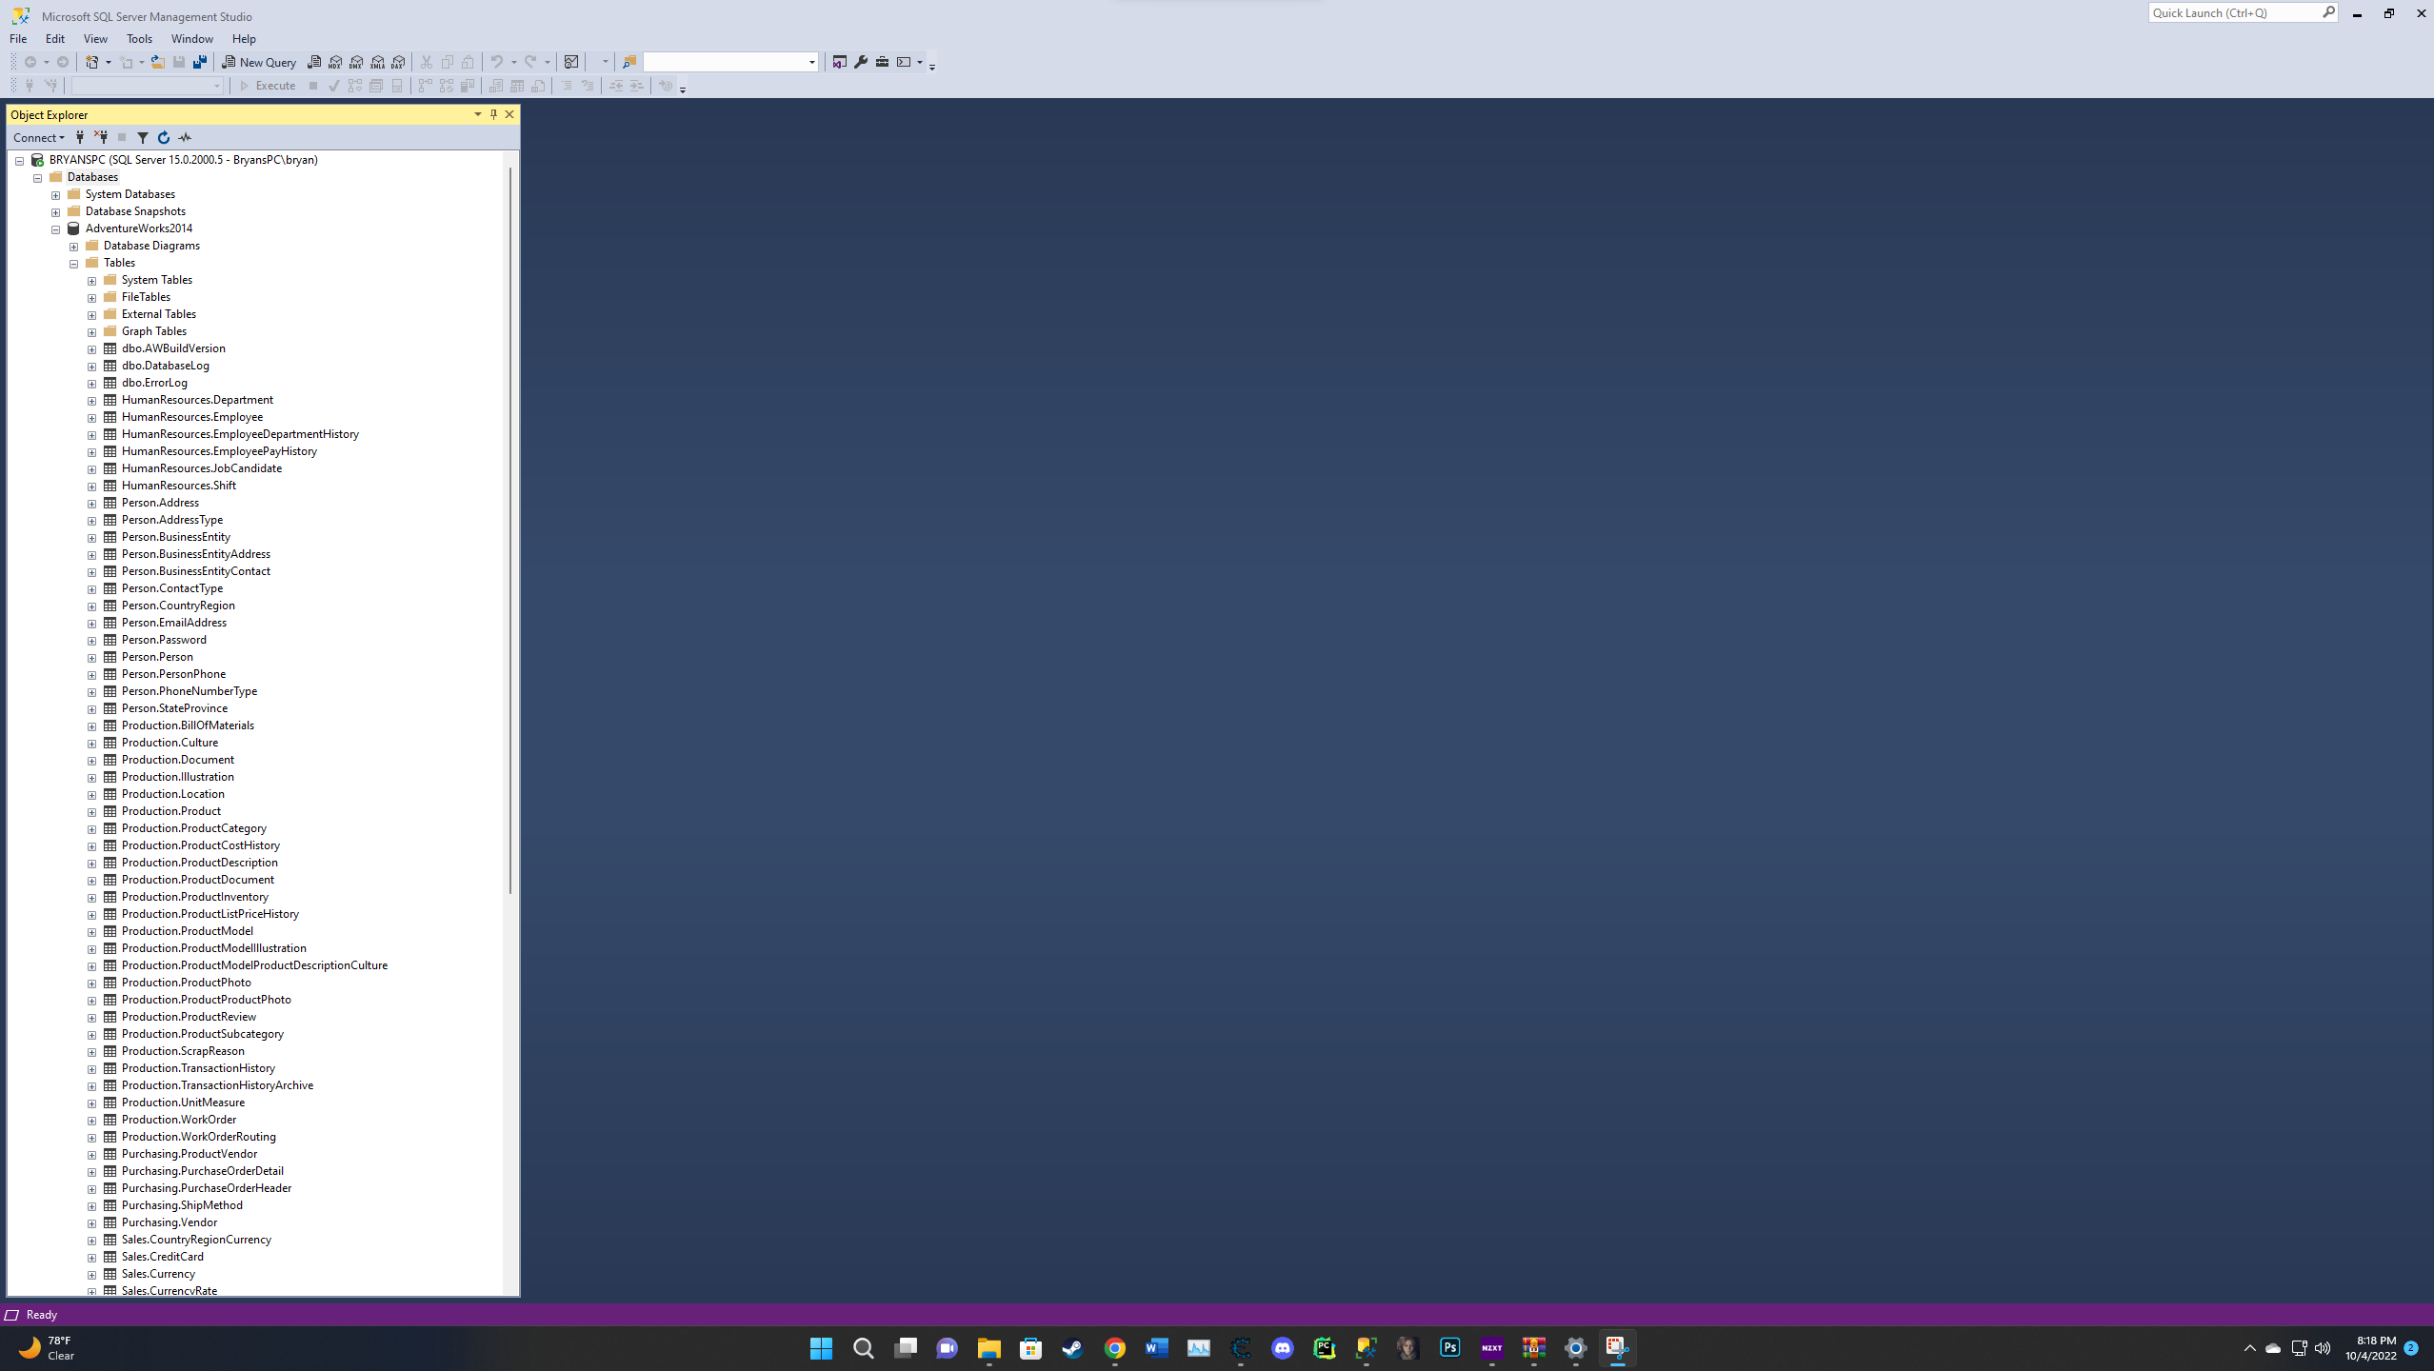

NOTE: For the questions below, it would be beneficial to review Module 4 (Creating Databases) to provide some grounding on the database options.
- Right-click on the “AdventureWorks2014” database and select the “properties” option as shown below:
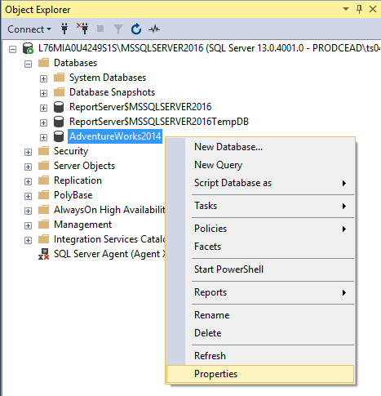

- ($$)DELIVERABLE – Using the “Database Properties” dialogue, answers to the questions below within this word doc:
  - How many files are used by the database?
2 Files which have both different file types and sizes. One named AdventureWorks2014_Data and AdventureWorks2014_Log.
  - Provide the names and sizes of the files in use.
The files have names such as “AdventureWorks2014_Log” and “AdventureWorks2014_Data”. When it comes to the size of the files the data one has 206MB while the log one has 18MB.

  - What’s the recovery mode for the database?
Recovery model for the database is set to simple.

  - What’s the collation for the database?
The collation of the database is set to SQL_Latin1_General_CP1_CI_AS.

  - What’s the compatibility level of the database?
The compatibility level of the database is set to SQL Server 2014(120)

  - Is the database set to Auto Update Statistics?
Yes, the database is set to True for auto update statistics.

  - Is the database set to Auto Shrink?
No, the database is set to false for auto shrink.

  - Is the database set to Auto Close?
No, the database is set to False for Auto Close.
- Next, let’s extract the DDL for the database. Right click on the AdventureWorks2014 database and make the selections as shown below:
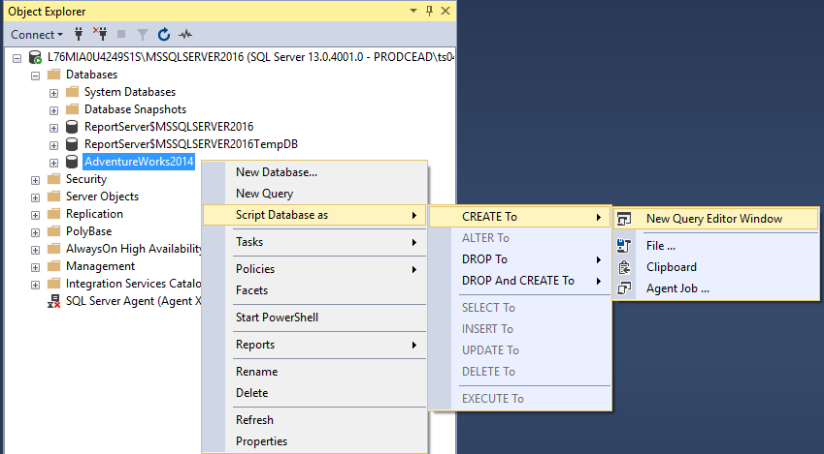
- ($$)DELIVERABLE - Copy the resulting SQL placed in the Query editor window and paste it to word doc below:
USE [master]
GO

/****** Object: Database [AdventureWorks2014] Script Date: 10/4/2022 10:11:07 PM ******/
CREATE DATABASE [AdventureWorks2014]
CONTAINMENT = NONE
ON PRIMARY
( NAME = N'AdventureWorks2014_Data', FILENAME = N'C:\Program Files\Microsoft SQL Server\MSSQL15.MSSQLSERVER\MSSQL\DATA\AdventureWorks2014_Data.mdf' , SIZE = 210176KB , MAXSIZE = UNLIMITED, FILEGROWTH = 16384KB )
LOG ON
( NAME = N'AdventureWorks2014_Log', FILENAME = N'C:\Program Files\Microsoft SQL Server\MSSQL15.MSSQLSERVER\MSSQL\DATA\AdventureWorks2014_Log.ldf' , SIZE = 18432KB , MAXSIZE = 2048GB , FILEGROWTH = 16384KB )
WITH CATALOG_COLLATION = DATABASE_DEFAULT
GO

IF (1 = FULLTEXTSERVICEPROPERTY('IsFullTextInstalled'))
begin
EXEC [AdventureWorks2014].[dbo].[sp_fulltext_database] @action = 'enable'
end
GO

ALTER DATABASE [AdventureWorks2014] SET ANSI_NULL_DEFAULT OFF
GO

ALTER DATABASE [AdventureWorks2014] SET ANSI_NULLS ON
GO

ALTER DATABASE [AdventureWorks2014] SET ANSI_PADDING ON
GO

ALTER DATABASE [AdventureWorks2014] SET ANSI_WARNINGS ON
GO

ALTER DATABASE [AdventureWorks2014] SET ARITHABORT ON
GO

ALTER DATABASE [AdventureWorks2014] SET AUTO_CLOSE OFF
GO

ALTER DATABASE [AdventureWorks2014] SET AUTO_SHRINK OFF
GO

ALTER DATABASE [AdventureWorks2014] SET AUTO_UPDATE_STATISTICS ON
GO

ALTER DATABASE [AdventureWorks2014] SET CURSOR_CLOSE_ON_COMMIT OFF
GO

ALTER DATABASE [AdventureWorks2014] SET CURSOR_DEFAULT GLOBAL
GO

ALTER DATABASE [AdventureWorks2014] SET CONCAT_NULL_YIELDS_NULL ON
GO

ALTER DATABASE [AdventureWorks2014] SET NUMERIC_ROUNDABORT OFF
GO

ALTER DATABASE [AdventureWorks2014] SET QUOTED_IDENTIFIER ON
GO

ALTER DATABASE [AdventureWorks2014] SET RECURSIVE_TRIGGERS OFF
GO

ALTER DATABASE [AdventureWorks2014] SET DISABLE_BROKER
GO

ALTER DATABASE [AdventureWorks2014] SET AUTO_UPDATE_STATISTICS_ASYNC OFF
GO

ALTER DATABASE [AdventureWorks2014] SET DATE_CORRELATION_OPTIMIZATION OFF
GO

ALTER DATABASE [AdventureWorks2014] SET TRUSTWORTHY OFF
GO

ALTER DATABASE [AdventureWorks2014] SET ALLOW_SNAPSHOT_ISOLATION OFF
GO

ALTER DATABASE [AdventureWorks2014] SET PARAMETERIZATION SIMPLE
GO

ALTER DATABASE [AdventureWorks2014] SET READ_COMMITTED_SNAPSHOT OFF
GO

ALTER DATABASE [AdventureWorks2014] SET HONOR_BROKER_PRIORITY OFF
GO

ALTER DATABASE [AdventureWorks2014] SET RECOVERY SIMPLE
GO

ALTER DATABASE [AdventureWorks2014] SET MULTI_USER
GO

ALTER DATABASE [AdventureWorks2014] SET PAGE_VERIFY CHECKSUM
GO

ALTER DATABASE [AdventureWorks2014] SET DB_CHAINING OFF
GO

ALTER DATABASE [AdventureWorks2014] SET FILESTREAM( NON_TRANSACTED_ACCESS = OFF )
GO

ALTER DATABASE [AdventureWorks2014] SET TARGET_RECOVERY_TIME = 0 SECONDS
GO

ALTER DATABASE [AdventureWorks2014] SET DELAYED_DURABILITY = DISABLED
GO

ALTER DATABASE [AdventureWorks2014] SET ACCELERATED_DATABASE_RECOVERY = OFF
GO

ALTER DATABASE [AdventureWorks2014] SET QUERY_STORE = OFF
GO

USE [AdventureWorks2014]
GO

EXEC [AdventureWorks2014].sys.sp_addextendedproperty @name=N'MS_Description', @value=N'AdventureWorks 2014 Sample OLTP Database'
GO

USE [master]
GO

ALTER DATABASE [AdventureWorks2014] SET READ_WRITE
GO

